**Project Execution Plan**

1.0 – Feb 5th, 2017 – Initial Version

# 1.0 Introduction

This document outlines the project execution plan for the development of a Complex Network model for networks with resource depletion, culminating in a Master’s Thesis for the Masters of Artificial Intelligence program offered by the Polytechnic University of Catalonia, developed by Cole MacLean with Sergio Gomez and Joan Matamalas as principle supervisors. Given the complexity of the project, some project management tools will be utilized for project development.

## 1.1 Project Scope

The aim of this investigation is to develop a model based on Complex Network theory capable of emulating and predicting the structure of a specific subclass of Complex Networks - those characterized by the existence of resource regeneration nodes connected by edges representing paths of resource depletion between these resource centers. The originating network studied for this subclass of networks subclass was Tesla’s electric vehicle Supercharger network, where Supercharges are the resource regeneration nodes, and the road networking connecting them being the resource depletion edges as electrical charge is consumed as a function of distance between the charging stations. Many other real-world networks have this resource depletion structure, including wireless transmission networks, pressurized pipeline systems and transportation infrastructure. The working hypothesis of this project is networks of this specific structure will have exploitable patterns capable of informing the development of a Complex Network model abstracting these structures into a generalizable network model.

This project will entail the collection, simulation, analysis and investigation of networks following the resource depletion structure, the development of a Complex Network model based on the observations made from these networks and validation of the final model in providing an abstracted generalization to networks following these structures.

# 2.0 Project Management

Various project management tools and techniques will be utilized to facilitate the development of this project.

## 2.1 Tooling

**Version Control**

* Git via github

**Scheduling and Task Assignment**

* Trello

**Scripting, Data-Munging and Model Devleopment**

* Python

## 2.2 Project Staging

There are 3 main stages to this project, with an optional 4th stage consisting of developing a production python package of the final model dependent on the final project timeline.

Stage 1: Data Collection/Simulation – This part of the project consists of gathering and/or simulating data for networks meeting the resource depletion structure requirement of this study.

Stage 2: Exploratory Data Analysis – This part of the project consists of manipulating and observing patterns in the collected data to inform hypothesis for the development of the final model

Stage 3: Model Development and Validation – This part of the project will test and validate the hypotheses developed in Stage 2.

Optional Stage 4: Production Python Package – Optionally develop and publish a project module consisting of the final model developed in this project, either stand-alone or part of python Networkx package.

Stage X: Literature Review – An ongoing literature review of prior work and Complex Network theory and models will be continuously performed in all stages to inform and provide foundation for the work.

## 2.3 Project Scheduling and Task List - Trello

The project management tool, Trello, will be utilized to create and schedule project tasks. This tool provides a shared interface for creating categorized lists of tasks and has tools for creating schedules and integrations with github.

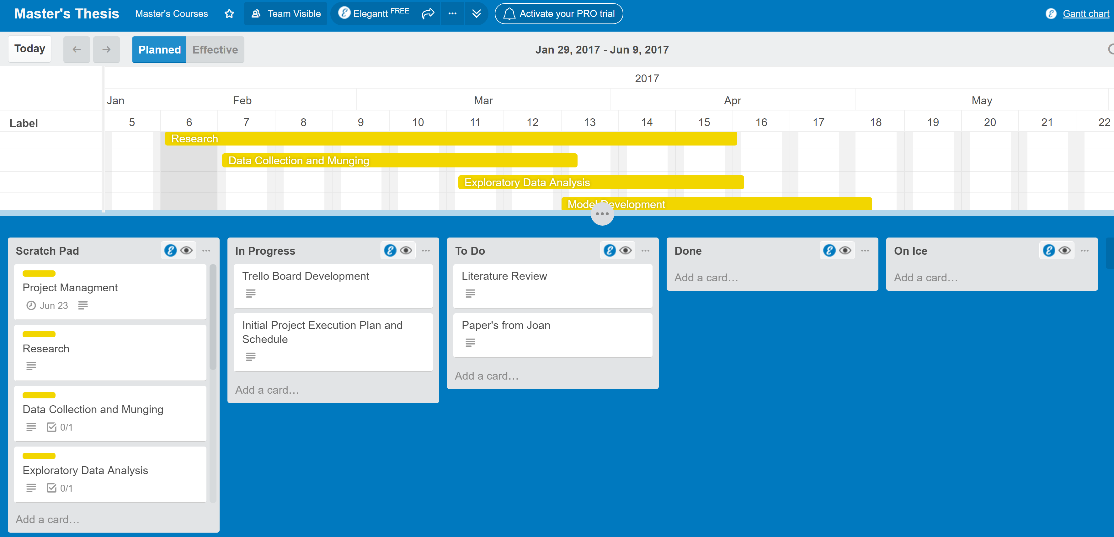

There are 4 main trello lists utilized for project management:

**Scratch Pad** – This is the idea generation list, where any team member can add an idea for the project to be documented and potentially executed. Ideas are added by selecting the general task group it belongs to, and adding the idea to the Idea Checklist within the general task group. Ideas can then be promoted to individual task cards for implementation by selecting the “Convert to Card” option on the listed task. This ensures that all ideas are captured, but only those requiring implementation become promoted into the workflow.

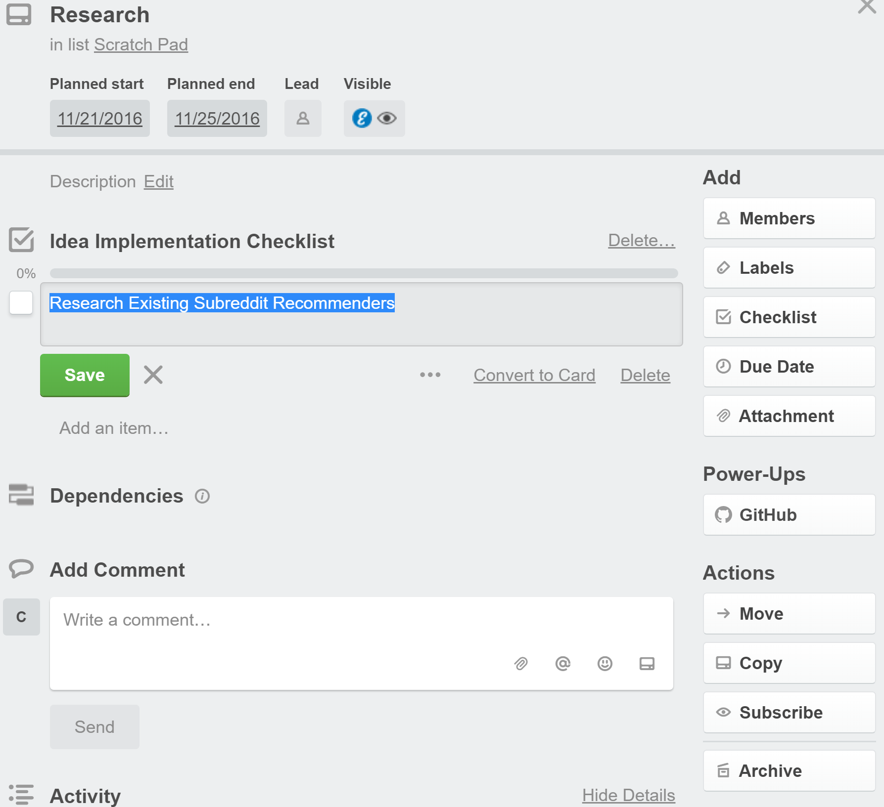

**To Do –** This list tracks all of the tasks that require implementation. Any team member can promote a Scratch Pad idea to the “To Do” list by making the idea an individual card and dragging it into the “To Do” list.

**In Progress –** This list tracks the task currently being executed.

**Done –** This list tracks all of the tasks successfully completed for the project. In order to promote a task from “In Progress” to “Done”, the following subtasks need to be completed.

* Code commenting and documentation
* Successful merge into Development
* Successful merge into Master

## 2.4 Version Control – GitHub

This project will utilize the GitHub source control infrastructure for project version control. The repository can be found [here](https://github.com/cole-maclean/thesis).

## 2.5 Project Schedule

The target completion date is the June Master’s Thesis period, with final report due for submission June 23, 2017 and final defense on July 3, 2017. The project schedule is managed through the project trello board, with high-level project task being yellow labelled.

